PRESS RELEASE  WP. C | Version 1  1/2022

Project information
Project Index Number: | CE1519
Project Acronym: | CHAIN REACTIONS
Project Title: | Driving smart industrial growth through value chain innovation
Website: | https://www.interreg-central.eu/Content.Node/CHAIN-REACTIONS.html
Start Date of the Project: | 01.04.2019
Duration: | 36 Months
Document Control page
Deliverable Title (overall): | WP. C. Press release
Lead Contractor of the Deliverable: | PP1 – PBN
Responsible PP: | PP1 – PBN
Authors: | PBN – Klaudia Keringer
Contractual Delivery Date: | 31.03.2022
Actual Delivery Date: | 16.03.2022

Project summary
The area of central Europe is well industrialised but not fully using the innovation potential generated by large leading corporations’ headquarters with strong research and development activities. As a result, the local small- and medium-sized companies (SMEs) show rather low performances in the indicator “innovating in-house and with others” as measured by the European Innovation Scoreboard.
The CHAIN REACTIONS project aims to increase the capacity of industrial businesses to innovate. The idea is to absorb new knowledge and turn it into competitiveness edge and business value, growth and profits. There is especially a need to help SMEs to overcome operational stress and a capacity shortage with respect to innovation as well as a stronger integration into emerging transnational and global value chains.
The project focuses on a few key sectors based on their embedding in regional smart specialisation strategies.
- Advanced manufacturing
- ICT and electronics
- Energy and environment
- Health
- Bioeconomy
The partnership successfully developed practical instruments (e.g. maturity models) to measure innovation potentials and capacities; set up triple helix “Innovation and Growth Alliances” and developed their capacity to support value chain innovation; and set up value chain observatories to analyse selected industrial sectors and their value chains.
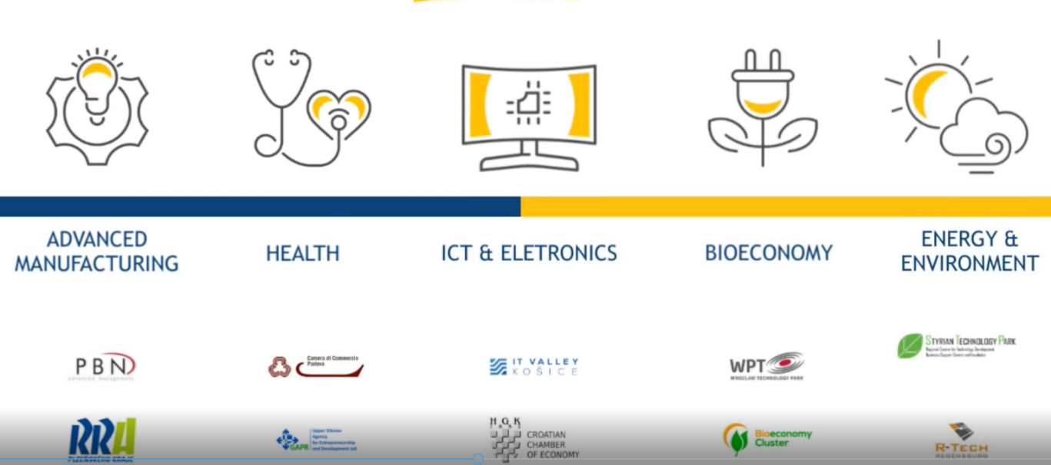
In each specialisation sector, the project partners successfully developed their interesting pilot actions.

The project ended with a successful international final conference, which was held online unfortunately due to the COVID-19 pandemic situation. The conference was attended totally by 50 participants, including relevant experts and actors from each represented field. The event also included a very interesting section, a roundtable discussion, which was based on the What are the professions of the future? EU policies for innovation topic.
Thankfully, the interactive session was attended by highly-skilled experts, who helped to widen the consortium’s knowledge and contributed with their very interesting and fascinating views for the future in the respected field of the Chain Reactions project.
Overall, the partners and experts agreed to continue their contribution and they are hoping for a cooperation in the near future in the key factor sectors of the Chain Reactions project.
Some example for the interesting pilot actions in each field:

E-Mobility in Germany: „Mobility needs Hydrogen” Bavaria's largest research and development network for hydrogen will be established in cooperation with OTH Regensburg and the Regensburg Chamber of Commerce for Upper Palatinate. The aim of the network is to develop new hydrogen-based technologies for mobility applications. For the R-Tech GmbH, which manages the e-mobilityy Cluster.
Virtual Innovation Observatory in Slovakia: The aim was to set up a virtual innovation observatory, which will provide innovation support services to target groups in bioeconomy through a multipartner cooperation. The goal of Bioeconomy Cluster is to identify the needs of agri-food sector and particular SMEs in respect to innovative business practices, to stimulate the exchange of knowledge between project partners and between SMEs and R&D actors and obviously to turn new ideas into practice by using different models and tools .
Training material in Poland: They would like to create a "knowledgeable one stop shop" offering pre-defined as well as tailor-made services for the medical industry. Namely, to timely and accurately respond to the needs of SMEs in med-tech sector who aim at internationalising regional value chains and industrial transition. The pillars: An IT platform – “virtual competence center”, E-learning on health sector internationalization combined with cross-sectoral collaboration, Laboratory for innovative business models.
Innovative showroom platform with advanced technological solutions in Poland: The pilot action conducted by WPT was aimed at creating a platform in the form of a showroom that would enable ongoing dialogue between companies from the food processing industry and entities offering advanced technological solutions. The platform was designed to identify entities from the food industry sector that are looking for innovative Industry 4.0 solutions and the digitization of production, management and sales processes.

Smart Senior Room in Hungary: The main motivating idea behind the idea of the so called “smart-senior-test-room” for elderly generation was the fact, which came out due to the COVID-19 situation. It became clear, that this generation is very vulnerable, especially in the case if they can’t get help from their family or their care giver. PBN would like to offer a solution with monitoring their health system and showing them different options (e.g. robots or apps) where they can not only ask for help, but can be used for entertainment functions as well.IGA members are involved in the pilot project as local policy makers like Szombathely City and Vas County are officially part of this initiatives and University level will be also involved in order to transfer knowledge to local citizens, too.
Innovation development of ICT in the region with a focus on e-health in Slovakia: The goal of the pilot activity is to deepen the dialogue between academia, business and public sectors, as well as to boost the delivery of new business ideas, to raise awareness of the challenges of industry 4.0 and the need to keep on the path of innovation development of ICT in the region with a focus on e-health. The tertiary goal is to attract the new workforce which is missed especially in SMEs.

Virtual demonstration centre for Advanced Manufacturing in Czech Republic: The Virtual demonstration center for Advanced Manufacturing is an online platform, where specific showcases of selected technologies will be demonstrated. So far, the following technologies/areas have been selected: virtual prototyping, additive manufacturing, robotics, virtual and augmented reality and objects digitization. Big stress is put on practical utilization thus each technology is documented by specific project with exact output and results which are visualized by videos or animations. The main idea of this platform is to promote the utilization of different technologies that SMEs could use for their innovation activities. Those particular showcases should in ideal way inspire the SMEs to take a similar action or at least to go in this direction. The second part of the Virtual demonstration center is focused on education. There is also additional learning material for individual technologies explaining the basic principles, usage and costs. Those learning materials are in form of downloadable pdf files by each technology.
Networking and boosting the development of new software ideas in Croatia: The aim of the pilot is to encourage innovation, find new software solutions and business partners, transnational and cross-sectoral cooperation and transfer of knowledge and experience. CCE-ZCC intended to achieve this through the involvement of various stakeholders in meetings, trainings, workshops, hackathon and matchmaking event. Within the pilot, 12 software solutions were developed in the field of advanced manufacturing and energy and environment, and through various events participated a large number of different stakeholders, from regional authorities, scientific and research community, universities, public companies, business support organizations, development agencies, clusters and of course SMEs.
Innovation paths for the biomedical sector in Italy:The pilot action has been carried on by the Italian partner, Padova Chamber of Commerce, a public sector organization promoting local development and innovation, especially among SMEs, which created a regional network for Innovation and has set up several specialized structures to foster the cooperation between Research and Industry, also together with the most relevant Business Associations and local Universities.
The pilot action tested in Veneto Region, Italy, is composed by two phases:
1) idea generation. Activities have been addressed to SMEs and innovation stakeholder in order to raise their knowledge on the opportunities of innovation, get in touch with other SMEs (even at transnational level), be aware about best practices in the sector and identify needs and expectations to be offered to innovators using “briefs”. The phase ended with the selection and publication of the briefs and the collection of possible solutions (innovative) offered by CCIs and Digital/High-tech SMEs/start-ups.
2)following the last step of the idea generation, the matching between briefs and selected proposals of innovation opened a coaching service addressed to 10 SMEs interested to work for new products, services and/or processes.
Partner introductions:

PBN: Pannon Business Network, for a decade and a half, the goal has been to increase the added value of manufacturing businesses. The audit of businesses, the coordination of clusters, and the analysis of transport corridors have led to a focus on digitization as a key trend. The accumulated knowledge has also been embodied in spatial development programs, ecosystem development and cooperation with leading European scientific institutions. As the best digital innovation center in Europe in 2020, am-LAB offers thematic programs with its own toolkit and a competitive research environment. The innovation center also supports the successful implementation of at.home's health developments and PBN's research and development projects.

STP: Established in 1994, STP is the first technological park in Slovenia and is dedicated to supporting businesses and potential new businesses. STP helps in the process of identification and implementation of business ideas as well as in growth period of a company, supporting SMEs throughout their entire life cycle. This also includes the transformation and optimisation of companies and above all implementation of innovation into the processes and products of SMEs. As the key factor in the regional SME support ecosystem, STP joined the Chain Reactions project to foster the implementation of transnational S3.

CCIAA Padova: Padova Chamber of Commerce, a public sector organization promoting local development and innovation, especially among SMEs, which created a regional network for Innovation and has set up several specialized structures to foster the cooperation between Research and Industry, also together with the most relevant Business Associations and local Universities.

CCE-ZCC Croatian Chamber of Economy – Zadar County Chamber: The Croatian Chamber of Economy is an independent professional and business organization of all legal entities engaged in business. It was established in 1852, and it is the oldest Croatian economic institution with continuous action. Territorially, the CCE consists of Headquarters in Zagreb and 20 County Chambers. One of them is the Zadar County Chamber, which is located in the city of Zadar, with the fundamental task of representing the interests of its members and cross-sectoral action for specific industries and professional groups.

RDA Pilsen: The Regional Development Agency of the Pilsen Region is non-profit company, which was established in 2000. The mission of the organization is to provide professional consulting services to support the economic and social development of the Pilsen region. One of the priorities is the creation of strategical documents to support research and development performance, smart specialization, and creation of innovation ecosystem in the region.

BWCON: Baden-Württemberg is one of the strongest economic regions in Germany and Europe. bwcon is the leading business initiative for the promotion of the high-tech sectors in the region with offices in Stuttgart, Freiburg, Horb and Villingen-Schwenningen. With its approximately 600 members since 1997, the main goal is to foster key-technologies in order to strengthen the region's economic development. The focus is on information and communication technologies (ICT) as drivers of innovation in the fields of mobility, production, health and energy. bwcon creates a unique platform for cross-sector collaboration between developers, users and investors.

WTP: Wrocław Technology Park is the largest business support organisation in Poland, in terms of the number of companies operating in its area. Their diversity, in the term of specialization, is proof for us that the WPT offer is adapted to the needs of various types of business, operating on every scale. WPT is a perfect place of operations for companies, entrepreneurs and scientists from the research and development sector, as well as research and development departments. Both startups, enterprises from the SME sector as well as large international companies will find their place here.
More information can be found here: https://www.technologpark.pl/en/

KEITVA: As the only cluster in Slovakia, Košice IT Valley holds a gold certificate from the European Commission - Gold Cluster Management Excellence. It currently has 60 members.The Košice IT Valley cluster’s vision is to create regional partnerships of IT companies, educational institutions, and regional governments. These will contribute to expanding and improving educational programs building a broad portfolio of job opportunities for the skilled workforce.

BEC: Bioeconomy Cluster creates an innovation ecosystem for the knowledge and technology transfer between research and agri-food industry including relevant policies through mutual cooperation. It is actively engaged in European and national policies in agricultural innovation, in supporting and networking of SMEs, as well as in connecting the entities of knowledge triangle. The thematic focus of BEC is on agri-food sector, with horizontal focus on bioeconomy and bio-based solutions.

R-Tech: The R-Tech GmbH was founded in 2001 as a subsidiary of the City of Regensburg and includes 25 staff members at the moment. The company operates the TechBase building to foster new technology businesses and startups offering high potential for innovation and growth and initiates applied university and science research projects. In addition, industrial businesses with research activities are involved and networks and technology clusters (e.g. HY2.ZERO – Mobility needs Hydrogen) are put into practice.

GAPR: Upper Silesian Accelerator for Commercial Enterprises Ltd. (GAPR) is a dynamic business support organization that provides services to SMEs, LCs and RTOs. As active regional stakeholder and leader of regional branch observatory in health (one of the S3 domains in Upper Silesia), GAPR is taking active role in supporting regional self-government in the process of regional innovation strategy implementation and monitoring. GAPR has a long history and experience in organizing B2B meetings, trade missions, facilitating business partnerships, improving business models through audits and trainings as well as providing customized businesses support for different sectors. GAPR offers infrastructure to business; mainly training rooms, offices, warehouses and production plants. As BSO GAPR manages MedSilesia cluster. The cluster is focused on medical technologies and devices as well as related services.

